Multiple-choice section – choose the correct answer

Question 1 [4.1]

The perimeter of the triangle below is:

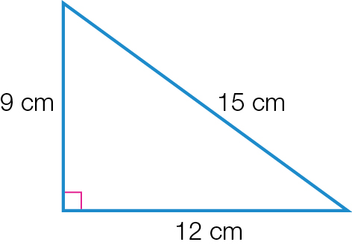

A 108 cm B 54 m C 36 m D 21 m

Question 2 [4.1]

The arc length of the sector below, correct to 2 decimal places, is:

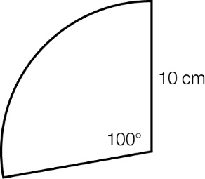

A 27.45 cm B 17.50 cm C 22.5 cm D 17.45 cm

Question 3 [4.1]

The perimeter of the compound shape below is:

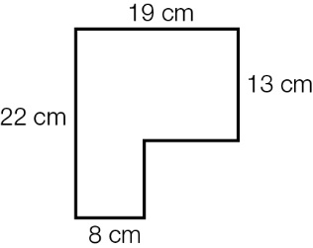

A 82 cm B 75 cm C 73 cm D 62 cm

Question 4 [4.2]

7.85 m2 is equivalent to:

A 785 cm2 B 78 500 cm2 C 7850 mm2 D 0.007 85 mm2

Question 5 [4.2]

The area of the parallelogram shown is:

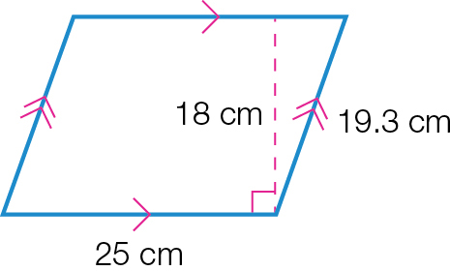

A 450 cm2 B 62.3 cm2 C 86 cm2 D 482.5 cm2

Question 6 [4.2]

The area of this composite shape is:

|  |  |
| --- | --- |
| ACPM9_PR_4_05tsa | A (10 × 5) + (10 × 6) cm2  B (10 × 11) + (× 10 × 6**)** cm2  C (10 × 15) + (× 10 × 6**)** cm2  D (10 × 5) + (× 10 × 6**)** cm2 |

Question 7 [4.3]

The surface area (SA) of the solid below is:

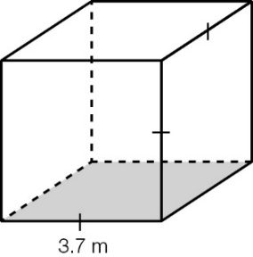

A 3.7 × 3.7 × 3.7 m2 B 6 × 3.7 × 3.7 m2 C 3.7 + 3.7 + 3.7 m2 D 4 × 3.7 × 3.7 m2

Question 8 [4.3]

The total surface area of the following prism is:

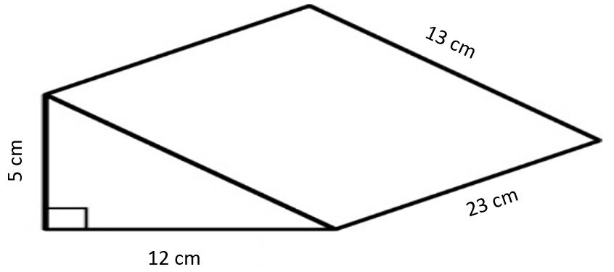

A 474 cm2 B 690 cm2 C 750 cm2 D 810 cm2

Question 9 [4.4]

95 500 mm3 is equivalent to:

A 0.955 m3 B 95.5 cm3 C 9.55 cm2 D 955 cm3

Question 10 [4.4]

The volume of this prism is:

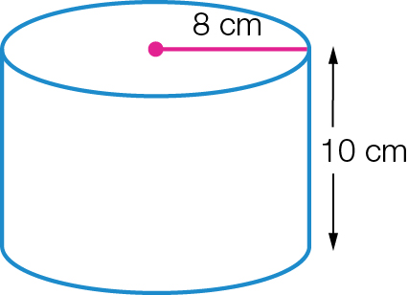

A π × 82 × 10 cm3 B π × 102 × 8cm3 C 10 × 16cm3 D 2 × π × 8 × 10cm3

Multiple-choice results: \_\_\_ / 10

Short answer section

Question 11 6 marks [4.1]

Calculate the perimeter of the following shapes (to 2 decimal places where necessary).

|  |  |  |
| --- | --- | --- |
| (a) | (b)  ACPM9_PR_4_10tsb_RR | (c)ACPM9_PR_4_11tsb |

Question 12 4 marks [4.1, 4.2]

Calculate the perimeter and the area of the following sector, correct to 2 decimal places.

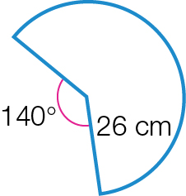

Question 13 2 marks [4.1]

Before school, Kate jogs around a rectangular area with dimensions 60 m by 35 m. If she jogs around this block six times, how far has she jogged? Give your answer in kilometres.

Question 14 4 marks [4.2]

Complete the following area conversions.

(a) 5.6 cm2 = \_\_\_\_\_\_\_\_\_\_\_\_\_\_\_ mm2

(b) 19.9 m2 = \_\_\_\_\_\_\_\_\_\_\_\_\_\_\_\_\_\_\_\_ cm2

(c) 123 000 cm2 = \_\_\_\_\_\_\_\_\_\_\_\_\_\_\_ m2

(d) 0.76 ha = \_\_\_\_\_\_\_\_\_\_\_\_\_\_\_ cm2

Question 15 6 marks [4.2]

Find the shaded areas of the following composite shapes (to 2 decimal places where necessary).

|  |  |
| --- | --- |
| (a)  ACPM9_PR_4_17tsb(2_RR) | (b)  ACPM9_PR_4_18tsb_RR |

Question 16 8 marks [4.3, 4.4]

For the following solids, find, correct to 2 decimal places:

(a) the surface area

(b) the capacity in litres

|  |  |
| --- | --- |
| (i)  ACPM9_PR_4_19tsa | (ii)  ACPM9_PR_4_20tsb |

Short answer results: \_\_\_ / 30

Extended answer section

Question 17 7 marks [4.1, 4.2, 4.4]

A roof of a shed made up of a rectangle with a triangle at one end is shown below.

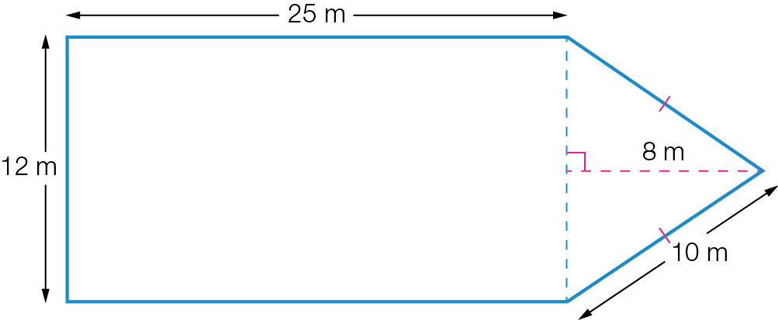

(a) Find the perimeter of the roof.

Gutters are to be installed around the edges of the roof at a cost of $4.50 per metre.

(b) Find the total cost of the gutters.

(c) Find the area of the roof.

(d) The shed also has a water tank with a capacity of 13.5 kL. How many cubic metres is the tank?

(e) It rained heavily and the water went straight into the tank. Given the area of the roof, at what depth would the rainwater need to be collected from the roof to completely fill the tank? Give your answer in centimetres, correct to 2 decimal places.

Question 18 8 marks [4.2, 4.3, 4.4]

David is landscaping his backyard. The diagram below shows that he will have a semicircular pond at the top end, along with two triangular garden beds on the sides of his trapezium yard. Apart from the pond and the garden beds, the rest of the backyard will be covered with buffalo grass.

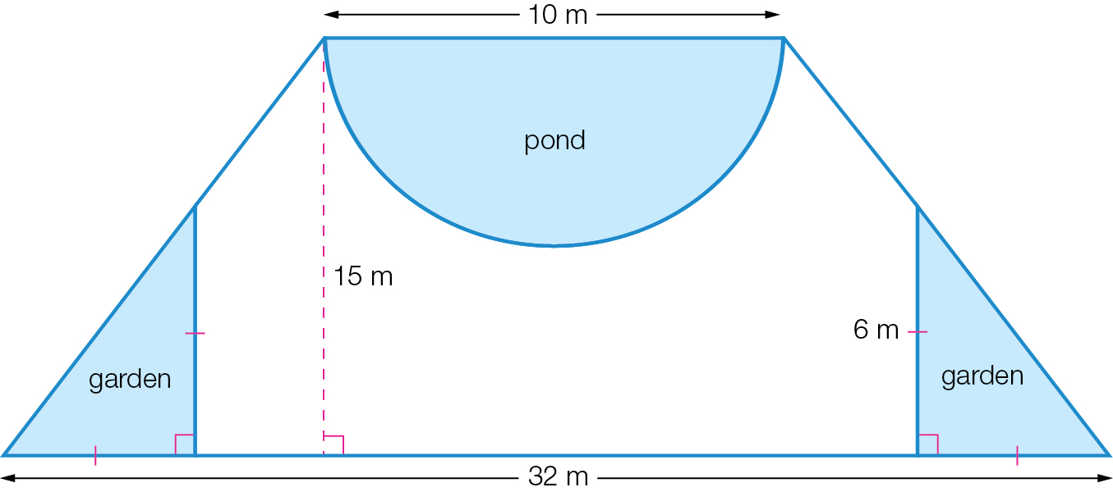

(a) (i) Find the area of David’s two garden beds.

(ii) If the soil needs to be 50 cm deep, how many cubic meters of soil does he need to purchase? Give your answer in cubic metres.

(b) The pond is 50 cm deep and in the shape of a semicylinder. If the side walls and the bottom of the pool need to be tiled, what is the total area of all the surfaces to be tiled? Give your answer to 2 decimal places.

(c) How many litres of water will be needed to fill the pond? Give your answer correct to the nearest litre.

(d) What area of the backyard will be covered with buffalo grass? Give your answer correct to 2 decimal places.

Extended answer results: \_\_\_ / 15

TOTAL test results: \_\_\_ / 55